James C. Everett
May 17, 1875 – August 20, 1875

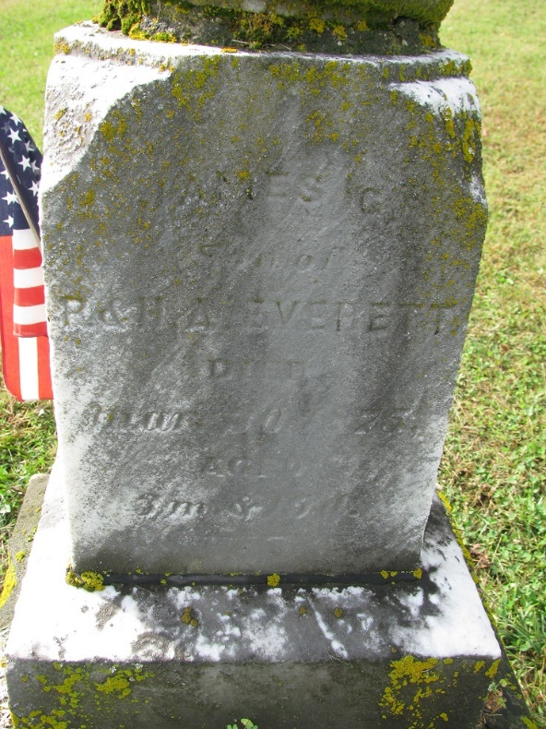
Photo by PLS

James C Everett from tree Fenstermacher/Reese/ Forney/Watts Family Tree
Birth 17 May 1875 Adams, Indiana, USA
Death 20 Aug 1875 Adams, Indiana, USA
Father Phillip Everett (1839-1876)
Mother Hannah Amanda Frisinger (1851-1912)

