Lydia Armintha (Fordyce) Eichar
January 15, 1837 – December 26, 1911

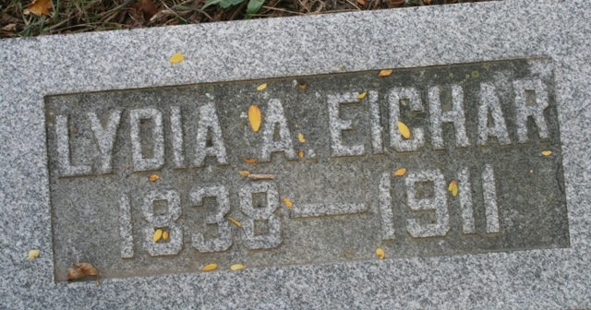
Photo by Barbara Baker Anderson

Ohio, County Death Records, 1840-2001

Name Lydia Arminth Eicher
Sex Female
Age 74y 11m 11d
Marital Status Widowed
Occupation House Wife
Race W
Father's Name John Fordyce
Mother's Name Mary Brown
Event Type Death
Event Date 26 Dec 1911
Event Place Willshire Township, Van Wert, Ohio, United States
Event Place (Original) Willshire Twp., Van Wert, Ohio
Cemetery Pleasant Mills
Birth Date 15 Jan 1837
Birthplace O
Burial Date 29 Dec 1911
Father's Birthplace Penn
Mother's Birthplace Virginia
Informant Mrs. Amands Schencke; Decatur, Indiana

