Loren Eichar
July 5, 1852 – April 9, 1861

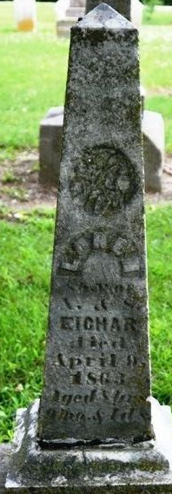
Photo by Deb Curry

Loren Eichar from tree Schadt
Birth 5 Jul 1852
Death 9 Apr 1861 Indiana, USA
Father A. Eichar
Mother S.

