David Eichar
March 4, 1830 – March 24, 1909

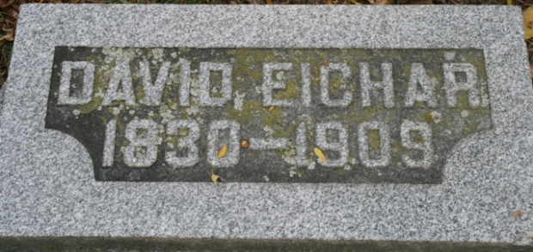
Photo by Barbara Baker Anderson

David Eichar, of Willshire, for many years a resident of St. Mary’s Township, died yesterday, heart trouble being the cause of death.
The funeral services will be held tomorrow morning at ten o'clock and interment will take place at Pleasant Mills.
The deceased was past seventy-five years old.

Decatur Daily Democrat; Adams County, Indiana
March 25, 1909

**
WAS BURIED TODAY
David Eicher, Former Resident of St. Mary’s Township
WAS FORTY-NINER
Made the Trip to the California Gold Field - Died Near Willshire

David Eichar, one of the most highly respected residents of this community passed away at his late home one mile east of town, Wednesday morning at about four o'clock. The immediate cause of his death was heart trouble, with which he had been suffering for some time, together with pleurisy, and bronchial affections.
Mr. Eichar was born March 4, 1830, being 79 years and 20 days of age at his death. He had been very poorly for some time but his death was sudden and unexpected at this time. At half past two o'clock Wednesday morning, Mrs. Eichar and Dot had been up with him, and turned him over, and at four o'clock he was heard to move a little, but nothing more was heard of him until upon arising, he was found to be lifeless.
He had spent practically all his life near Pleasant Mills, until he moved to the farm east of town, except when a young lad, he went to the California gold fields, being one of the original 'forty-niners', and one of the few who survived the hardships of that time.
The funeral services will be held at the house Friday morning at ten o'clock conducted by Rev. J. H. Walters, and the interment will be in the cemetery at Pleasant Mills. --Willshire Herald

Decatur Daily Democrat; Adams County, Indiana
March 26, 1909

