Gladys Wilma Durbin
September 17, 1904 – May 30, 1916

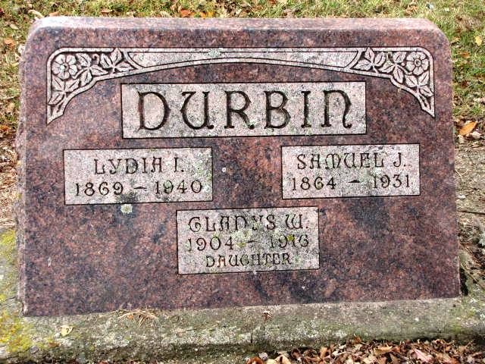
Photo by Barbara Baker Anderson
Obit from Karin King

Young Adams County Girl is Dead

Decatur, Ind., May 31 – Gladys Wilma Durbin, twelve, daughter of Samuel J. Durbin of St. Mary’s Township, is dead after a short illness occasioned by spinal trouble.
Two parents, two sisters and one brother, Mrs. Laura Gehris, Bessie Durbin and Harry Durbin survive. William H. Martz is her grandfather.
The funeral will be held Thursday afternoon at 1:30 oclock at the M.E. Church at Pleasant Mills, the Rev. Conway officiating.

Fort Wayne Journal-Gazette (Allen County, Indiana)
June 1, 1916, Page 13

