William Thomas Douglass
January 31, 1842 – March 9, 1882

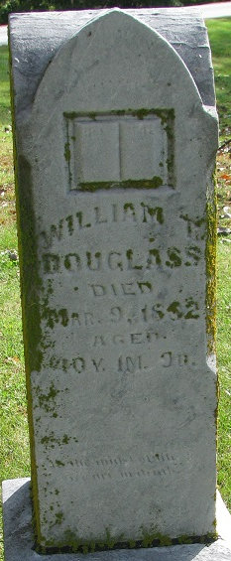
Photo by PLS

William Thomas Douglas from tree Tricia Bollenbacher Haworth Family Tree
Birth 31 Jan 1842 Indiana, USA
Marriage 26 Dec 1864 Adams, Indiana, USA
Residence 1880 Adams, Indiana, USA
Death 9 Mar 1882 Indiana, USA
Father Samuel Theodore Scott Douglass (1808-1843)
Mother Lucretia Jane Davis (Douglass-Stacy) (1815-1888)
Spouse Elsie S Mathewson (1846-1920)

