Ronald Wayne Coughman
July 17, 1878 – June 6, 1879

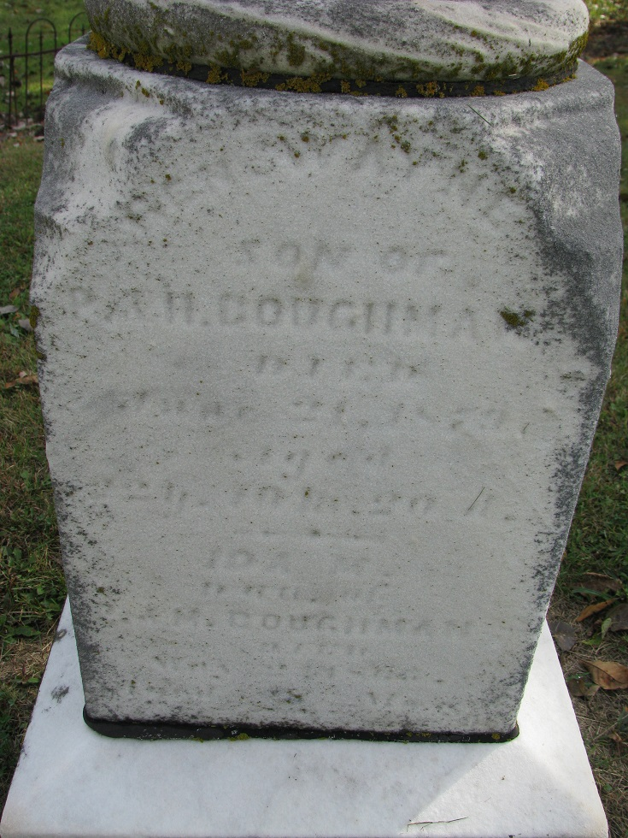
Photo by PLS

No further information found at this time

