John Coughman
April 1, 1862 – April 16, 1865

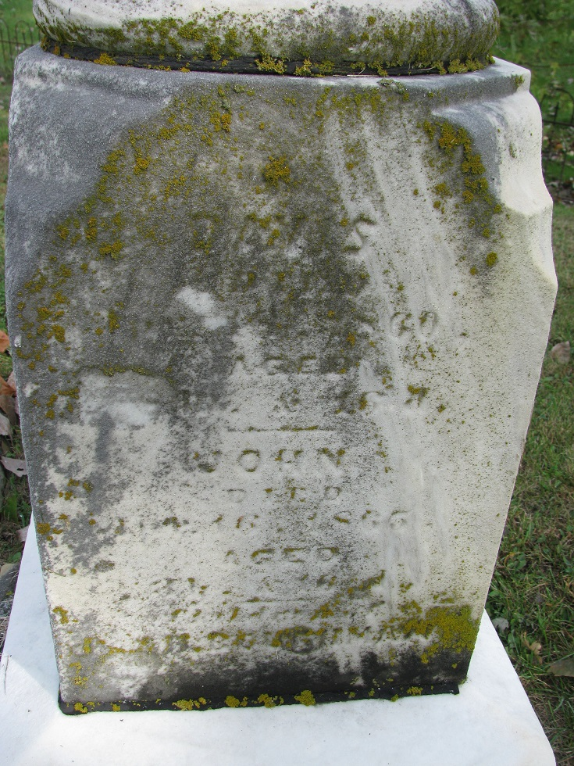
Photo by PLS

No further information found at this time

