Ida B. Coughman
1865 - 1865

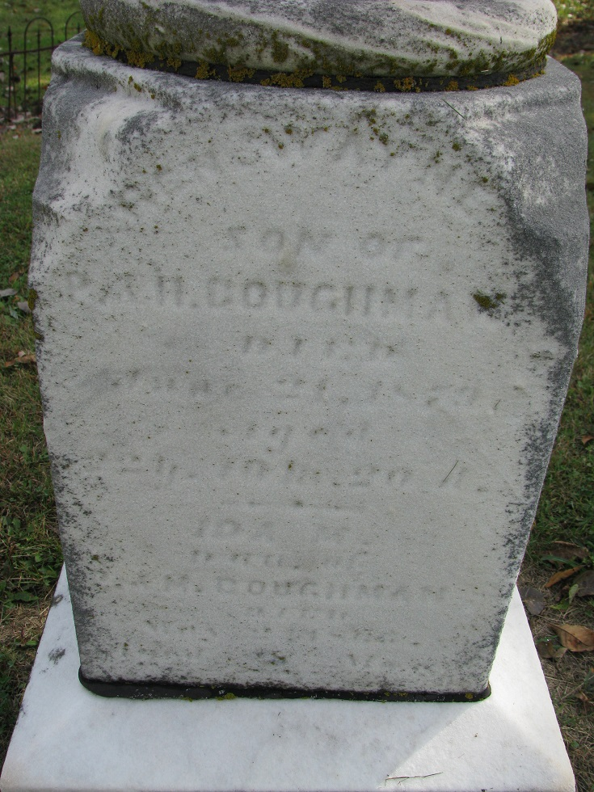
Photo by PLS

No further information found at this time

