Davis Coughman
July 31, 1859 – April 16, 1860

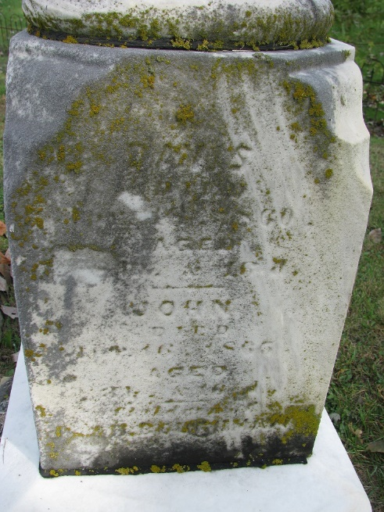
Photo by PLS

No further information found at this time

