Weldon E. Cook
February 17, 1882 – October 25, 1897

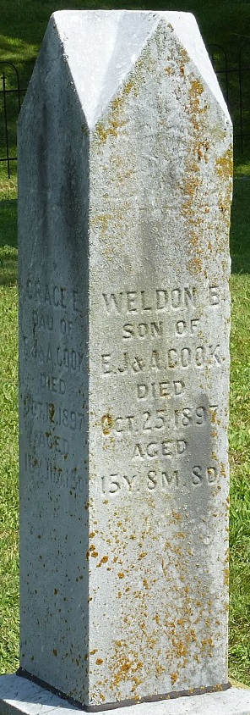
Photo by Robert Ashton

Weldon, the fifteen-year-old son of Elmer Cook of Monroe Township, died Sunday and was buried Monday afternoon at Pleasant Mills. This is the third death from typhoid fever in Mr. Cook's family within a short time.

Decatur Democrat; Adams County, Indiana
Thursday, October 28, 1897

**
Weldon Cook from Jones Family Tree
Father Jonathan Elmore Cook
Mother Alice Tippy
Birth 17 Feb 1882 Decatur, Adams, Indiana, USA
Death 25 Oct 1897 Decatur, Adams, Indiana, USA

