Grace E. Cook
October 28, 1880 – October 12, 1897

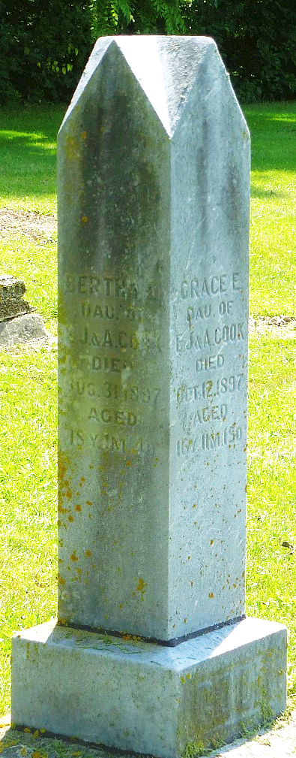
Photo by Robert Ashton

Grace Cook
in the Indiana, U.S., WPA Death Index, 1882-1920
Name Grace Cook
Date Oct 12, 1897
Location Honroe
Age 17 Yr
Gender Female
Race White
Source location County Health Office, Decatur
Source notes The source of this record is the book H-19 on page 188 within the series produced by the Indiana Works Progress Administration.
**
Grace E. Cook from tree Jones Family Tree
Birth 28 Oct 1880 Decatur, Adams, Indiana, USA
Death 12 Oct 1897 Decatur, Adams, Indiana, USA
Father Jonathan Elmore Cook (1857-1935)
Mother Alice Tippy (1854-1941)

