Florence L. Cook
September 20, 1887 – September 19, 1902

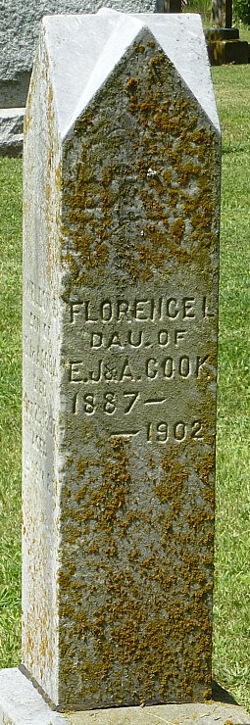
Photo by Robert Ashton

Miss Florence Cook, fifteen years old, died Friday evening of typhoid fever after a short illness. She was the daughter of Mr. and Mrs. Elmer Cook and was well known. Funeral services were held at Pleasant Mills Sunday evening.
Decatur Democrat; Adams County, Indiana
A weekly newspaper
Thursday, September 25, 1902
**
Florence, the fifteen-year-old daughter of Elmer Cook, living four miles southwest of Pleasant Mills, died last Friday of typhoid fever. The funeral services were held at the U. B. Church at this place Sunday morning, conducted by Rev. Speck of the Sanctified sect. The funeral was one of the largest held at this place for some time.
Florence was said to be a girl beloved by all who knew her.
The parents and friends have our sincere sympathy in their sad hour of trial. She was laid to rest by the side of her brother and sisters.

Decatur Democrat; Adams County, Indiana
A weekly newspaper
Thursday, September 25, 1902
**
Indiana, U.S., Death Certificates, 1899-2017
Name Florence Cook
Gender Female
Race White
Marital Status Single
Age 14
Birth Date 20 Sep 1887
Birth Place Washington Township
Death Date 19 Sep 1902
Death Place Washington, Adams, Indiana, USA
Death Registration Date 1902
Father Elmer J Cook
Mother Alice Tippy
Informant Elmer J. Cook; Monroe, Indiana
Burial September 21, 1902; Pleasant Mills, Indiana

