Bertha D. Cook
July 27, 1879 – August 31, 1897

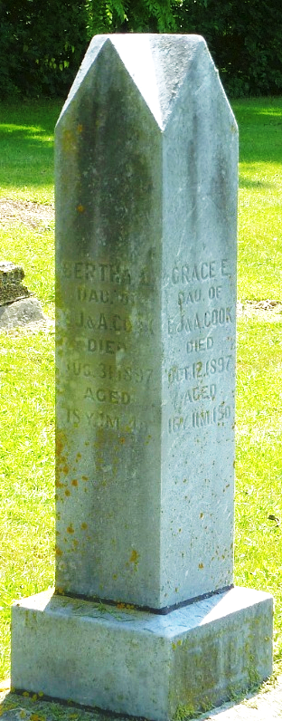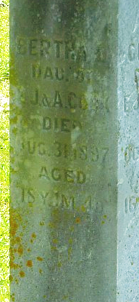
Photo by Robert Ashton

Bertha D. Cook
in the Indiana, U.S., WPA Death Index, 1882-1920
Name Bertha D. Cook
Date Aug 03, 1897
Location Monroe
Age 18 Yr
Gender Female
Race White
Source location County Health Office, Decatur
Source notes The source of this record is the book H-19 on page 186 within the series produced by the Indiana Works Progress Administration.
**

Bertha D. Cook from tree Jones Family Tree
Birth 28 Jul 1879 Decatur, Adams, Indiana, USA
Residence 1880 Kosciusko, Indiana, USA
Death 31 Aug 1897 Decatur, Adams, Indiana, USA
Father Jonathan Elmore Cook (1857-1935)
Mother Alice Tippy (1854-1941)

