Rebeca (Hughes) Coffman
April 3, 1813 – October 2, 1872

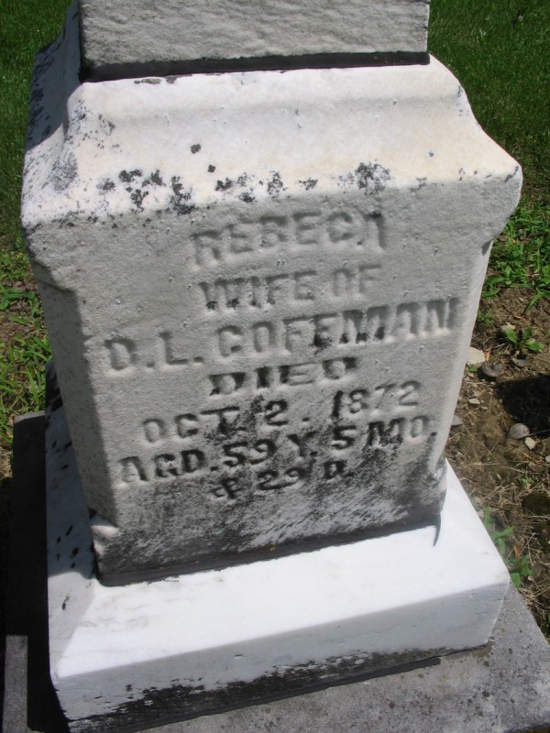
Photo by Margie Roop Pearce

Fairfield Co, OH Marriage Records, book 3, p 198
Coffman, David and Huges, Rebecca
married 18 Aug 1831; by Jesse Spurgeon
Marriage Book 1803-1835, third section, page 198
Probate Court Records.
**

Rebecca Hughes Huges Coffman from tree CLRM 2014
Birth 3 Apr 1813 Lancaster, Fairfield, Ohio, USA
Marriage 18 Aug 1831 Fairfield, Butler, Ohio, USA
Residence 1870 Adams, Indiana, USA
Death 2 Oct 1872 Pleasant Mills, Adams, Indiana, USA.
Father Jesse Hughes (1787-1864)
Mother Mary A. Hardesty (Hardisty or Hardestry) (1790-1844)
Spouse David Lowe Coffman (1811-1871)

