David Lowe Coffman
February 5, 1811 – August 1, 1871

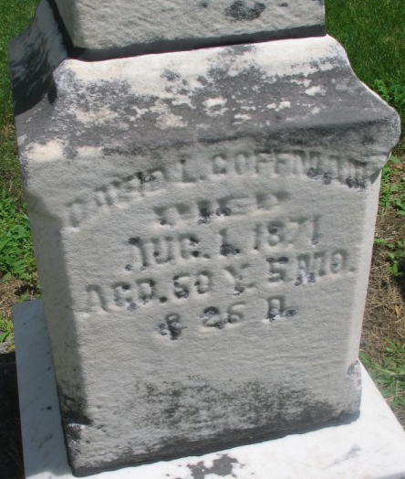
Photo by Margie Roop Pearce

Adams County, IN Wills

David L. Coffman; Makes his last will & testament; May 11, 1871
Rebecca Coffman; Wife; Inherits personal property & rents & profits from real estate
Harriet Olive; Daughter; to inherit additional 100.00 after death of mother
Henry Steele; Executor; To lay marble slabs at graves of David & Rebecca Coffman
Jesse H. Coffman; Son; to share estate with siblings after death of mother
Benjamin P. Coffman; Son; to share estate with siblings after death of mother
George M. Coffman; Son; to share estate with siblings after death of mother
Mary E. (Coffman) Hendricks; Daughter; md to Bazzle Hendricks; share estate with siblings Bazzle Hendricks; Husband of Mary E. Coffman
Sarah Ann (Coffman) Steele; Daughter; md to Henry Steele; share estate with siblings
Henry Steele; Husband of Sarah Ann Coffman
Harriet O.; Daughter; to share estate with siblings after death of mother
Isabel W. (Coffman) Springer; Daughter; md to David Springer; share estate with siblings Charles McLeod; Grandson; son of John McLeod & Rhoda Jane (deceased)
Charles McLeod; Grandson; to inherit 1/3 of the amount that other heirs inherit
John McLeod; Father of Charles McLeod; hus of Rhoda Jane Coffman, deceased
Rhoda Jane (Coffman) McLeod; Deceased daughter of David Coffman; hus of John McLeod;
John S. Harper; Witnessed David Coffman making his last will & testament
James Miller; Witnessed David Coffman making his last will & testament
John Schrank; Witnessed David Coffman making his last will & testament
David L. Coffman; Died on or about Aug. 1, 1871
John Harper; Subscribing witness; oath of death & validity of will of David Coffman; Aug. 31, 1871
A. J. Hill; Clerk; will has been admitted to probate; Aug. 31, 1871
**

David Lowe Coffman from Davis Family Tree
Spouse Rebecca Hughes
Father Martin Coffman
Mother Sarah Whitehouse
Children Sarah Ann
Birth 5 Feb 1811 Hocking, Fairfield, Ohio, USA
Death 1 Aug 1871 Pleasant Mills, Adams, Indiana, USA
Residence 27 Apr 1859 Pleasant Mills, Adams, Indiana, USA

