Benjamin P. Coffman
December 31, 1846 – August 23, 1872

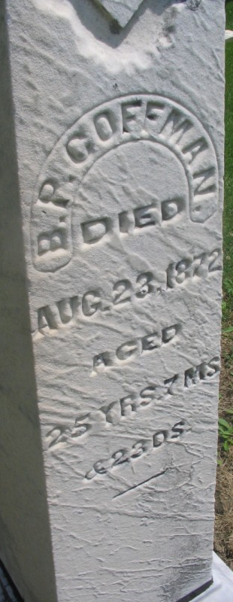
Photo by Margie Roop Pearce

Benjamin P. Coffman in Michael Allan Horn tree
Spouse Susan Harper
Father David Lowe Coffman
Mother Rebecca Hughes
Children Nettie
Birth 31 Dec 1846 Adams, Indiana, USA
Death 23 Aug 1872 Pleasant Mills, Adams, Indiana, USA
Residence 1 Jun 1870 Adams, Indiana, USA

