Samuel S. Chronister
March 22, 1865 – November 18, 1871

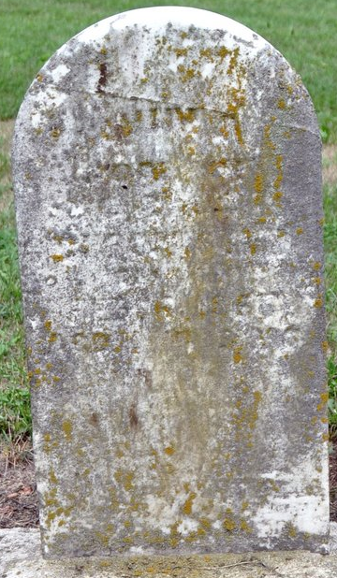
Photo by Deb Curry

Samuel S. Chronister from tree CHRONISTER
Birth 22 Mar 1865 Indiana, USA
Residence 1870 Adams, Indiana, USA
Death 18 Nov 1871 Pleasant Mills, Adams, Indiana, USA
Father Conrad Casper Chronister (1827-1905)
Mother Catherine Lenhart (1827-1917)

