John R. Chronister
May 10, 1855 – August 29, 1856

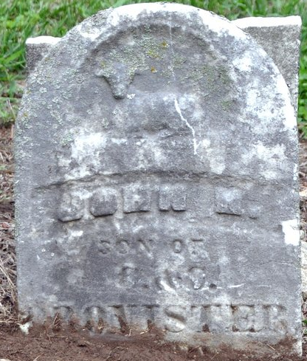
Photo by Deb Curry

John R. Chronister from tree Sanders Family Tree
Birth 10 May 1855
Death 29 Aug 1856
Father Conrad Casper Cronister (1827-1905)
Mother Catherine Lenhard (Chronister) (1827-1917)

