Irvin A. Chronister
May 6, 1853 – February 6, 1855

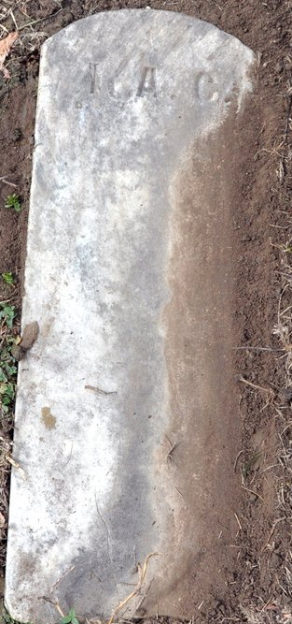
Photo by Deb Curry

Irvin A. Chronister from tree Sanders Family Tree
Birth 6 May 1853
Death 6 Feb 1855
Father Conrad Casper Cronister (1827-1905)
Mother Catherine Lenhard (Chronister) (1827-1917)

