Mille M. Browning
May 31, 1869 – May 19, 1887

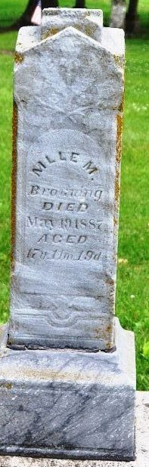
Photo by Deb Curry

Mlle M Browning from tree Daniel Family Tree
Birth 31 May 1869 Allen, Indiana, USA
Death 19 May 1887 Allen, Indiana, USA
Father James H Browning (Born 1838)
Mother Hannah E Showers (1848-1886)
24761 People 1 Record 1 Source

