Hannah E. (Showers) Browning
February 6, 1848 – April 10, 1886

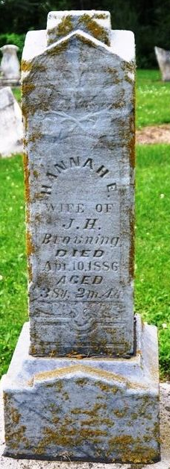
Photo by Deb Curry

Hannah E Showers from tree Yoder, Zopfi, Kranze, Ellison, Barnard, Dodd, Vogler
Birth 6 Feb 1848 Decatur, Adams, Indiana, USA
Residence 1870 Jefferson, Jackson, Ohio, USA
Marriage 6 Apr 1875 Adams, Indiana, USA
Death 10 Apr 1886 Indiana, USA
Father David Showers (1819-1898)
Mother Milbre Godard (1827-1887)
Spouse William H Browning

