Phoebe Ellen (Hayworth) Brown
February 7, 1837 – October 5, 1923

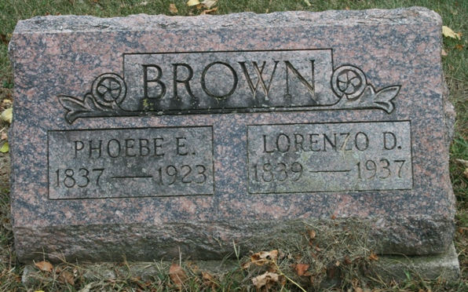
Photo by Jacquie Eisenhut

LONG MARRIED LIFE IS ENDED
Death of Mrs. L. D. Brown, of Pleasant Mills, Ends Long Companionship

Mrs. L. D. Brown, 89, one of the oldest residents of Pleasant Mils, died at 10:30 o’clock last night, following an illness due to a broken hip. Mrs. Brown fell on June 16, breaking her hip, and she had been bedfast since that time.
Mrs. Brown was born in Miami County, Ohio, February 7, 1837. She had lived in Pleasant Mills for twenty-four years. Almost 67 years ago she was married to L. D. Brown, their 67th wedding anniversary being next Monday, the date of Mrs. Brown’s funeral.
Eight children were born to Mr. and Mrs. Brown, two of whom are living. They are Mrs. O.J. Suman of Pleasant Mills and Ora A. Brown, of Fort Wayne. Eliza Hayworth, of Greentown, is a sister of Mrs. Brown. The aged husband also survives.
Mrs. Brown was a member of the Christian Newlight Church.
Funeral services will be held from the Methodist Church in Pleasant Mills at 1:30 o’clock Monday afternoon, the Rev. Maupin officiating. Burial will be made in the Pleasant Mills Cemetery.

Decatur Daily Democrat, Adams County, Indiana
Saturday, October 6, 1923

**
Indiana, Death Certificates, 1899-2011

Name: Pheba Ellen Brown
[Pheba Ellen Hawarth]
Gender: Female
Race: White
Age: 86y, 1m, 29d
Marital status: Married
Birth Date: 7 Feb 1837
Birth Place: Ohio
Death Date: 5 Oct 1923
Death Place: Pleasant Mills, Adams, Indiana, USA
Father: Euclidus Hawarth
Mother: Anna Coppock
Spouse: Lorenzo D Brown
Informant: Mrs. O J Suman, Pleasant Mills
Burial: Oct 8, 1923, Pleasant Mills

