Samuel W. Brandyberry
January 21, 1863 – March 5, 1889

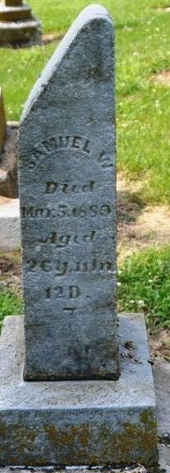
Photo by Deb Curry

Samuel W. Brandyberry in A Haggerty Family Tree
Father Jonathan Brandyberry
Mother Harriett Smith
Birth 21 Jan 1863 Adams, Indiana, USA
Death 5 Mar 1889 Adams, Indiana, USA
Residence 1870 Adams, Indiana, USA

