Orpha M. Brandyberry
July 9, 1877 – September 30, 1893

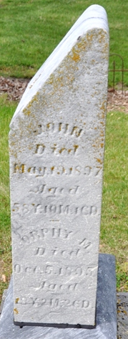
Photo by Deb Curry

St. Paul Items
Miss Orpha Brandyberry, a faithful member of the St. Paul church, departed from this life of toil and care last Sunday morning, October 1, 1893. She leaves a bright remembrance of her past life to her friends and relatives. They know she has no more sorrow and pain. She was loved by all who knew her.

Decatur Democrat, Adams County, Indiana
October 6, 1893

**
Adams Co, IN WPA Death Index

Brandyberry Orpha F W age 20, d. Sept 30 1893 Adams Co Bk. H-19, p 130.
Stone: October 5, 1893

**
Orpha M. Burkhead from tree Cherryholmes-Tritschler-Milliken-Reichanadter Family Tree
Birth 9 Jul 1877 Adams, Indiana, USA
Death 30 Sep 1893 Adams, Indiana, USA
Father John Brandyberry (1838-1897)
Mother Harriett Smith (1832-1914)

