Henry J. Brandyberry
January 28, 1855 – February 11, 1855

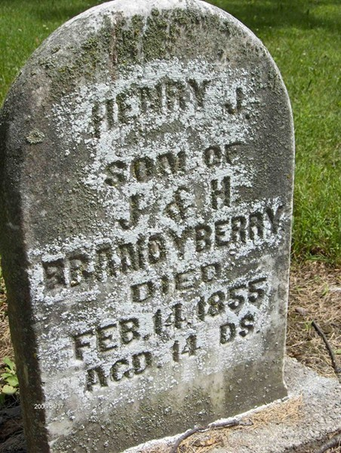
Photo by Margie Roop Pearce

Henry J. Brandyberry in A Haggerty Family Tree
Father Jonathan Brandyberry
Mother Harriett Smith
Birth 28 Jan 1855 Adams, Indiana, USA
Death 11 Feb 1855 Adams, Indiana, USA

