Harriet M. Brandyberry
May 28, 1878 – October 5, 1895

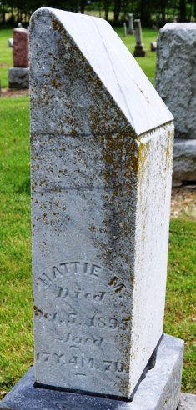
Photo by Deb Curry

No further information found at this time

