Catharine Victoria Brandyberry
August 3, 1874 – July 3, 1886

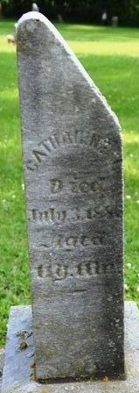
Photo by Deb Curry

Catherine Victoria Brandyberry from tree Lofthouse_2011-09-01(1)
Birth 3 Aug 1874 Allen, Indiana, USA
Residence 1880 Adams, Indiana, USA
Death 3 Jul 1886 Allen, Indiana, USA
Father Jonathan Brandyberry (1838-1897)
Mother Harriet Smith (1832-1914)

