Mary E. Braddock
April 16, 1843 – March 26, 1863

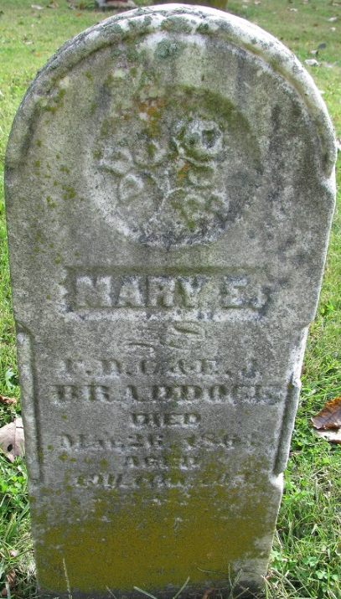
Photo by PLS

Mary E. Braddock from tree Kinder/Newman Family Tree
Birth 16 Apr 1843
Death 26 Mar 1863
Father Francis D. C. Braddock (1814-1888)
Mother Elizabeth J. Gregory (1823-1881)
5846 People 1 Record 1 Source

