Elizabeth J. (Gregory) Braddock
December 28, 1823 – January 24, 1881

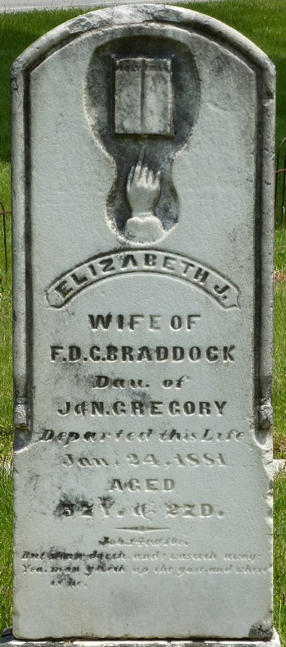
Photo by Deb Curry

Elizabeth Gregory from tree Holzapfel Family Tree
Birth 28 Dec 1823
Marriage 27 Feb 1840 Delaware, USA
Death 24 Jan 1881 Indiana, USA
Father John Gregory (1798-1842)
Mother Nancy Shideler (1802-1887)
Spouse Francis D. C. Braddock (1814-1888)

