Ida B. (Marquardt) Boner
October 15, 1870 – June 30, 1900

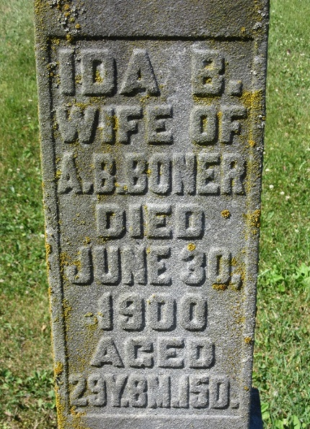
Photo by PLS

Chas. Smith and family of Bluffton were here Tuesday to attend the funeral of Mrs. Smith's sister, Mrs. Al Boner.
Decatur Democrat; Adams County, Indiana
A weekly newspaper
Thursday, July 4, 1901

**
Mrs. Albert Boner died Sunday at two o'clock, after several years suffering with consumption. Before her marriage she was Miss Ida Belle Marquette [sic - Marquart]. She was thirty-one years old at the time of her death and leaves a husband and two sons to mourn her early demise. She was a good wife and mother and a model housekeeper.
Her funeral occurred at the residence Tuesday morning after brief, but impressive, services by Rev. L. D. Brown.
Decatur Democrat; Adams County, Indiana
A weekly newspaper
Thursday, July 4, 1901

**
Mrs. Mary Albury of Van Wert, Ohio, attended the funeral of her niece, Mrs. Al Boner, at this place Tuesday.
Decatur Democrat; Adams County, Indiana
A weekly newspaper
Thursday, July 4, 1901

**
Ida B Marquadt from tree Ritchhart & Downey Family
Birth 15 Oct 1870 Monroeville, Allen, Indiana, USA
Residence 1880 Allen, Indiana, USA
Death 30 Jun 1900 or June 30, 1901 Pleasant Mills, Adams, Indiana
Father George W Marquadt (Born 1834)
Mother Emeline Shoemaker
Spouse Albert Boner

