Mary Blaney
1862 - 1863

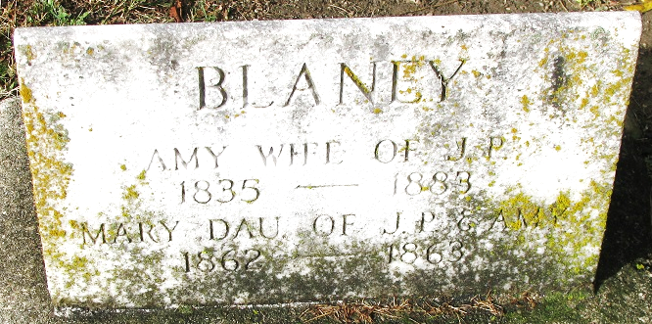
Photo by PLS

No further information found as of this date

