Amy Elizabeth (Winans) Blaney
1835 - 1883

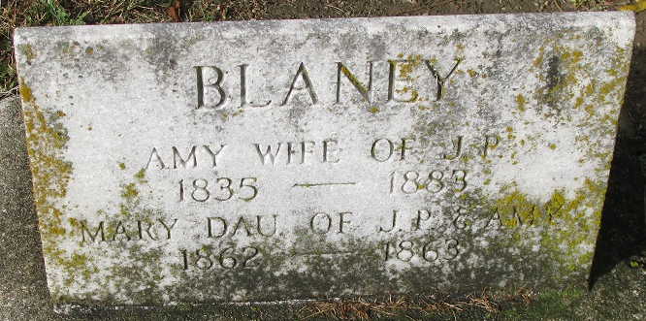
Photo by PLS

Indiana Marriage Collection, 1800-1941
Name: A E Winans
Spouse Name: John Blaney
Marriage Date: 19 Sep 1858; Marriage County: Adams
Source: Adams County, Indiana Index to Marriage Records 1845 - 1920 Inclusive Vo; W. P. A. Original Record Located County Clerks Off; Book: B, OS Page: 259
**
Amy Elizabeth Winans from tree Henry Gephart and Mary Elizabeth Vinegar Family Tree
Birth 1835 (or 1841, 1842 or 1843) Indiana, USA
Marriage 11 Sep 1858 Allen, Indiana, USA
Residence 1880 Adams, Indiana, USA
Death 1883
Father Joseph Ross Winans (1817-1878)
Mother Nancy Heath (Born 1820)
Spouse John P Blayney (1837-1910)

