Harriet Olive “Hattie” (Coffman) Beery
April 29, 1838 – December 7, 1908

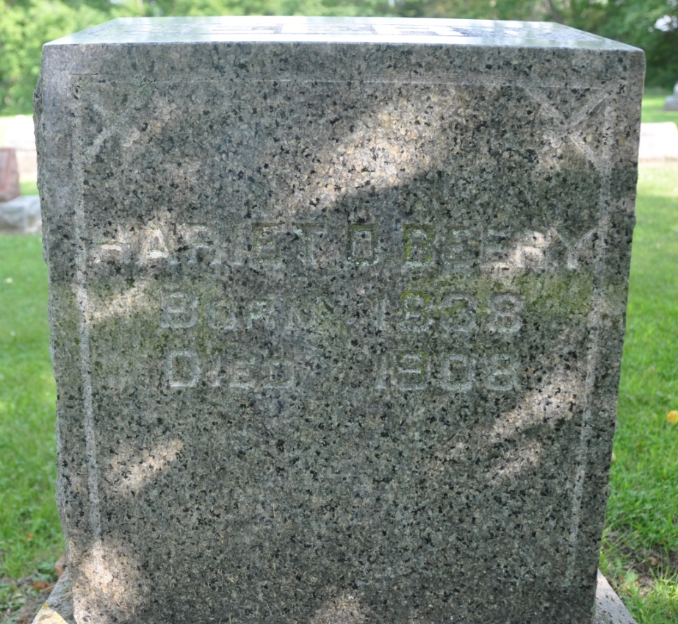
Photo by Deb Curry
Obit from Karin King

LIVED LONG LIFE - Mrs. Hattie, Wife of Late Abraham Beery, Died This Morning at 4:20 O'Clock - CREEPING PARALYSIS
Signaled the Coming of the Death Angel - Was 71 Years of Age

Her body enveloped by creeping paralysis and the infirmities of old age contributing to the seriousness of the ailment foretokened inevitable death, Mrs. Hattie, the widow of seven months of the late Abraham Beery, breathed her last at the home of her niece, Mrs. George Roop, this morning at 4:20 o'clock. Though a sufferer for years, the decedent has withstood the ravages of a complication of ailments with wonderful vitality and it was not until the inception of the creeping paralysis that there were evidences of her early demise. This dread disease, however, is deadly in its sweep and but few young survive its attendant effects much less a woman whose age numbers in the three score ten. The deceased, at one time the wife of Alex Eichar, became the wife of Mr. Beery about eight years ago, subsequent to the death of her first husband, who was, prior to his death, one of Adams county's wealthiest residents. She was born in Ohio, April 29, 1838. Most poignant sorrow follows the death of such an estimable woman and besides a multitude of grief stricken friends, the following share in the bereavement: two sisters, Mrs. David Springer, Van Wert, and Mrs. H. Steele, of Pleasant Mills; two brothers, Jesse Coffmann [sic], a retired farmer of Kansas and another brother who is a banker in California. The funeral services will be held from the Pleasant Mills M. E. church tomorrow afternoon, the cortege leaving Decatur at 12:30 o'clock.

Decatur Daily Democrat, Adams County, Indiana
Monday, December 7, 1908
*****
Kansas, Compiled Marriage Index from Select Counties, 1854-1873

Name: EICHAN, Alexander (55)
Spouse: COFFMAN, Hattie (45)
Marriage Date: 15 Feb 1884
County: Neoshoks
Film Number: LDS FILM #0851639
Source: LDS FILM #0851639; TYPED INDEX NOT ORIGINAL RECORDS. ?XXXX?= YEAR RECORDED, NO DATE KNOWN
*****
Indiana, Marriages, 1810-2001

Name: Hattie Coffman Eicher
Gender: Female
Race: White
Event Type: Marriage Registration (Marriage)
Birth Place: Ohio
Marriage Date: 3 Sep 1901
Marriage Place: Indiana, United States
Residence Place: Kansas
Father: Daniel Coffman
Mother: Rebecca Hagg
Spouse: Abraham J Beery
Page: 116
*****
Indiana, Death Certificates, 1899-2011

Name: Hattie Beery
[Hattie Coffman]
Gender: Female
Race: White
Age: 70y, 7m, 8d
Marital status: Widowed
Birth Date: 29 Apr 1838
Birth Place: Ohio
Death Date: 7 Dec 1908
Death Place: Decatur, Adams, Indiana, USA
Father: David Coffman
Informant: ? Steele
Burial: Dec 8, 1908, Pleasant Mills

