Fred Bauman
November 27, 1902 – March 19, 1974

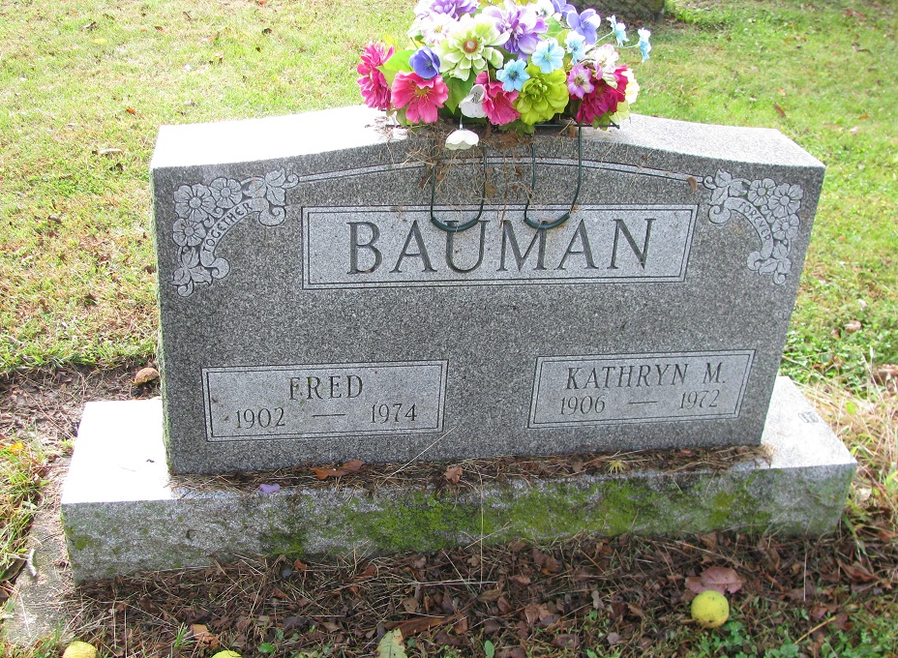
Photo by PLS
Obit from Janice Vasilovski

Fred Bauman, 71, Dies This Morning

Fred Bauman, 71, of route 6, just west of Pleasant Mills, a farmer and barber in Adams County for 50 years, died at 9:45 a.m. today at the Adams County Memorial Hospital, where he had been hospitalized two days.
Born in Adams County on Nov. 27, 1902, he was a son of John and Anna Kneuss-Bauman, and was married on Aug. 20, 1925, to Martha K. Sherburn, who died June 16, 1972.
Surviving are five children, John E. Bauman of Decatur; Mrs. Richard (Lois) Cook of route 6, Decatur; Glen A. Bauman of route 6, Decatur; Richard L. Bauman of Fort Wayne, and Mrs. Raymond (Norma) Ballard of Clovis, New Mexico; one sister, Mrs. Emery (Ella) Beebe of Ceresco, Mich.; two brothers, Sam Bauman of Climax, Mich., and Edward Bauman of Battle Creek, Mich., 12 grandchildren and two great-grandchildren. One son and one brother preceded him in death.
Funeral services will be held at 1:30 p.m. Friday at the Zwick Funeral Home, with Rev. William McClintock and Rev. Joe Gibson officiating. Burial will be in the Pleasant Mills Cemetery. Friends may call at the funeral home after 7 p.m. Wednesday.

Decatur Daily Democrat, Adams County, Indiana
Tuesday, March 19, 1974

