Charles William Bauman
January 30, 1929 – February 5, 1929

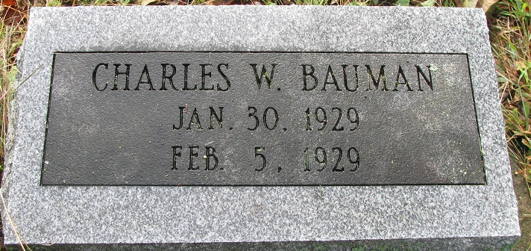
Photo by PLS

Charles William Bauman
in the Indiana, U.S., Death Certificates, 1899-2017
Name Charles William Bauman
Gender Male
Race White
Age 5 days
Birth Date 30 Jan 1929
Birth Place Indiana
Death Date 5 Feb 1929
Death Place Pleasant Wills, Adams, Indiana, USA
Death Registration Date 1929
Father Fred Bauman
Mother Katherine Sherburn
Informant Fred Bauman; Pleasant Mills, Indiana
Burial February 6, 1929; Pleasant Mills Cemetery

