Elizabeth (Warfield) Barnhart
July 17, 1831 – July 18, 1855

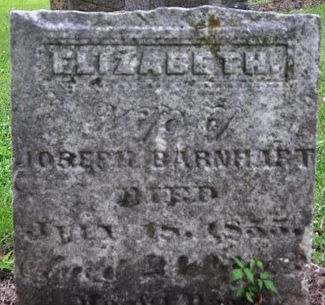
Photo by Deb Curry

Elizabeth Warfield from tree Craig Karmann family tree
Birth 17 Jul 1831 New York, USA
Marriage 24 Jun 1850 Ohio, USA
Residence 1850 Allen, Darke, Ohio, USA
Death 18 Jul 1855 Indiana, USA
Father William Warfield (1801-1860)
Mother Hannah Buckalew (1801-1860)
Spouse Joseph Brickley Barnhart (1829-1856)

