David Barnhart
November 5, 1830 – July 23, 1854

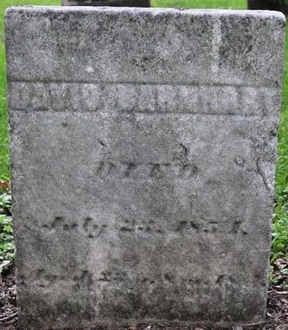
Photo by Deb Curry

Indiana Marriage Collection, 1800-1941
Name: Isabella Flag; Spouse Name: David Barnhart
Marriage Date: 30 Dec 1852; Marriage County: Adams
Source: Adams County, Indiana Index to Marriage Records 1845 - 1920 Inclusive Vo; W. P. A. Original Record Located County Clerks Off; Book: B, OS Page: 125

**
David Barnhart from tree P Egnew Family Tree
Birth 5 Nov 1830
Marriage 28 Dec 1852 Adams, Indiana, USA
Death 23 Jun/July 1854 Adams, Indiana, USA
Father Michael Barnhart (1786-1832)
Mother Catharine Bobo (1785-1833)
Spouse Isabella Flagg Barnhart (1835-1919

