Sulma (Billman) Barnett
October 24, 1842 – March 8, 1922

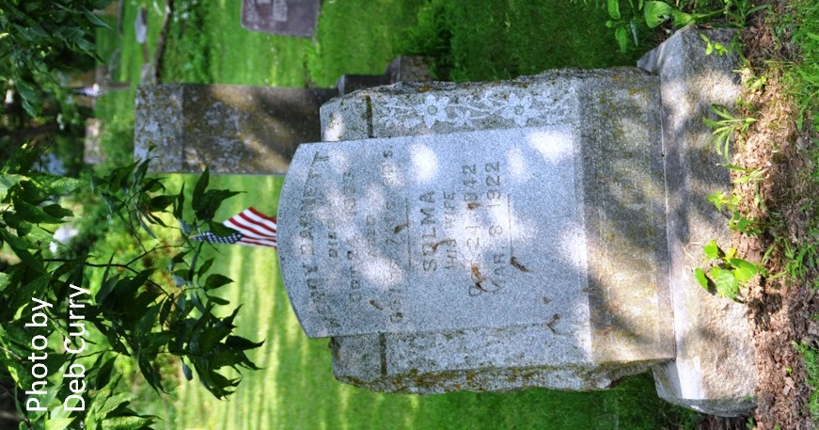
Photo by Deb Curry

AGED LADY DEAD
Mrs. Solma Barnett Passed Away Last Night at Her Home on Ninth Street
DEATH WAS RESULT Of Infirmities of Age and Complications - Seriously Ill Three Months

After having been in a serious condition for the past three months suffering from complications resulting from a tumor and from general infirmities due to old age, Mrs. Solma Barnett, aged 80 years, widow of the late Henry Barnett, passed away at twelve o'clock last night at her home on Ninth street.
Mrs. Barnett had been in rather poor health for some time and for the past three months had been confined to her bed. Owing to the nature of the disease and to her advanced age there had been but very little hope extended for her recovery, and while her death came as a very great sorrow to the relatives and friends, it was not entirely unexpected.
Mrs. Barnett was born in Pennsylvania on October 24, 1842, being the daughter of Mr. and Mrs. Gideon Billman. In 1860 she was united in marriage to Mr. Henry Barnett and they made their home for a number of years near Pleasant Mills. Shortly after Mr. Barnett's death in 1903, Mrs. Barnett moved to this city where she has continued to make her home until the time of her death.
The deceased is survived by the following children: Gideon of Redkey, Ind., Edward of Toledo, Mrs. Cora Crole of Plainwell, Michigan, Mrs. Lydia Nelson of Howard City, Mich., Mrs. Edna Ashbaucher of Hammond, Ind., John Barnett and Mrs. Ed. Kintz of this city. Two sisters and one brother also survive, they being Mrs. Caroline Walls of Lima, Ohio, Mrs. Becky Liggett of Fort Wayne and Henry Billman of Michigan.
Short funeral service will be held at the home Saturday afternoon after which the remains will be taken to Pleasant Mills where interment will be made.

Decatur Daily Democrat, Adams County, Indiana
March 9, 1922

**
Indiana, Death Certificates, 1899-2011
Name: Salma Barnett
[Salma Bilman]
Gender: Female
Race: White
Age: 74
Marital status: Widowed
Birth Date: 24 Oct 1842
Birth Place: Penn
Death Date: 8 Mar 1922
Death Place: Decatur, Adams, Indiana, USA
Father: Gideon Bilman
Mother: Lydia Gable
Spouse: Henry Barnett
Informant: John Barnett; Decatur, Indiana
Burial: March 11, 1922; Pleasant Mills Cemetery

