Glenn Milo Barnett
February 19, 1895 – October 8, 1896

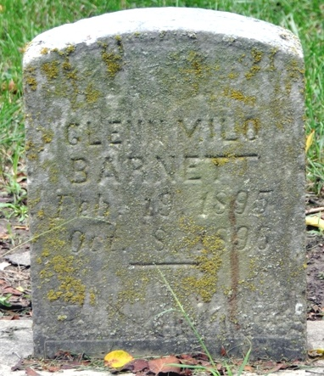
Photo by Deb Curry

The funeral of Glenn Barnett, the little son of John Barnett, who was burned to death at Bluffton Thursday, occurred at Pleasant Mills Saturday. The funeral concourse left Bluffton this morning at 7 o'clock, driving overland. Many friends of the bereaved family attended from this city.
**
PLEASANT MILLS
The funeral of John Barnett's little daughter [sic], of Bluffton, occurred at the M.E. Church last Saturday. Interred in the Pleasant Mills Cemetery.
**
The little child of John Barnett, which was so badly burned in the fire at Bluffton, Thursday night, died three hours after the fire. The child was asleep upstairs above the restaurant and immediately above the fire. The father, seeing the perilous position of the child, prompted by a father's love, rushed through the flames, grabbed his babe and escaped to the street, but only after being seriously burned himself. The mother and father are prostrate with grief over the sad death of their little son.
All from Decatur Democrat, Adams County, Indiana
A weekly newspaper
Thursday, October 15, 1896

