Eva Delora Barnett
May 20, 1870 – December 20, 1884

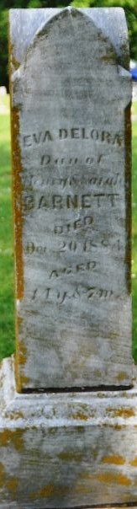
Photo by Deb Curry

Eva Delora Barnett from tree Hammond Family Tree
Birth 20 May 1870 Indiana, USA
Residence 1880 Adams, Indiana, USA
Death 20 Dec 1884 Adams, Indiana, USA
Father Henry Barnett (1838-1903)
Mother Sarah Billman (1844-1922)

