Esther Ann Barnett
July 13, 1874 – June 22, 1891

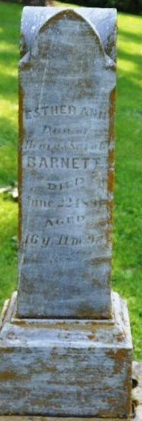
Photo by Deb Curry

Esther Ann Barnett from tree Roop_File_2023-02-23
Birth 13 Jul 1874
Death 22 Jun 1891 Allen, Indiana, USA
Father Henry Barnett (1838-1903)
Mother Sarah Billman (1842-1922

