Iva F. Ayres
July 20, 1887 – October 7, 1897

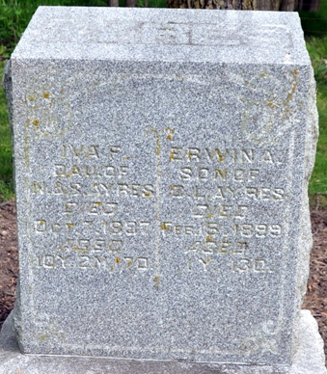
Photo by Deb Curry

Iva F. Ayres from tree Janet Trease family tree
Birth 20 Jul 1887
Death 7 Oct 1897 Pleasant Mills, Adams, Indiana, USA
Father Nathan A Ayers (1846-1917)
Mother Sarah Jane Chapman (1849-1921)

