Erwin A. Ayres
January 2, 1898 – February 15, 1899

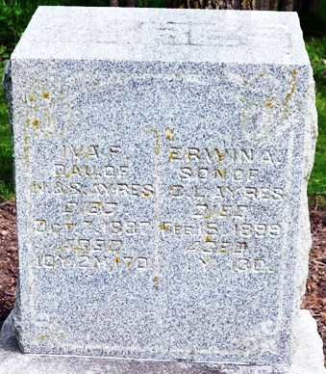
Photo by Deb Curry

From Thursday's Daily
Erwin Ayers [sic], the 1-year-old son of Mr. and Mrs. Clarence Ayes, died at the home of A. L. Ayers, near Pleasant Mills, yesterday, of pneumonia. The funeral will be held at the house tomorrow. Interment at Pleasant Mills. Mrs. Ayers is lying very low with nervous prostration.
Decatur Weekly Journal, Adams County, Indiana
Friday, February 17, 1899
**

Erwin Ayers,infant son of Mr. and Mrs. Clarence Ayers, died at the home of A. L. Ayers south of the city last Wednesday evening of pneumonia, aged one year and thirteen days.
Funeral services were held from the house on Friday. Interment at Pleasant Mills Cemetery.
Mrs. Ayres who has been very ill is reported some better.

Decatur Democrat, Adams County, Indiana
Thursday, February 23, 1899
**

From Friday's Daily
The funeral services of Erwin Ayers, the 1-year-old son of Mr. and Mrs. Clarence Ayers, of Marion, were held from the residence of A. L. Ayers, this morning. Rev. W. H. Daniel conducted the services. The interment was at Pleasant Mills.
Decatur Weekly Journal, Adams County, Indiana
Friday, February 24, 1899

