Mary A. (Leffel) Armstrong
July 22, 1831- December 21, 1921

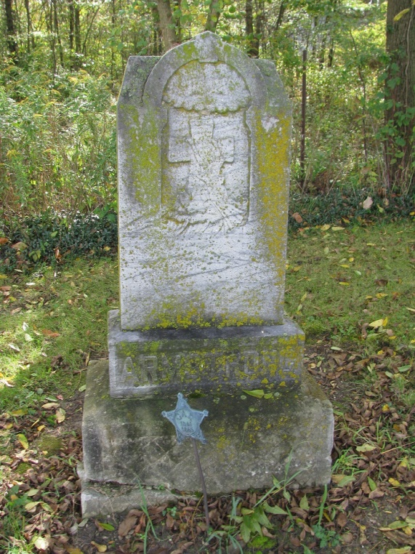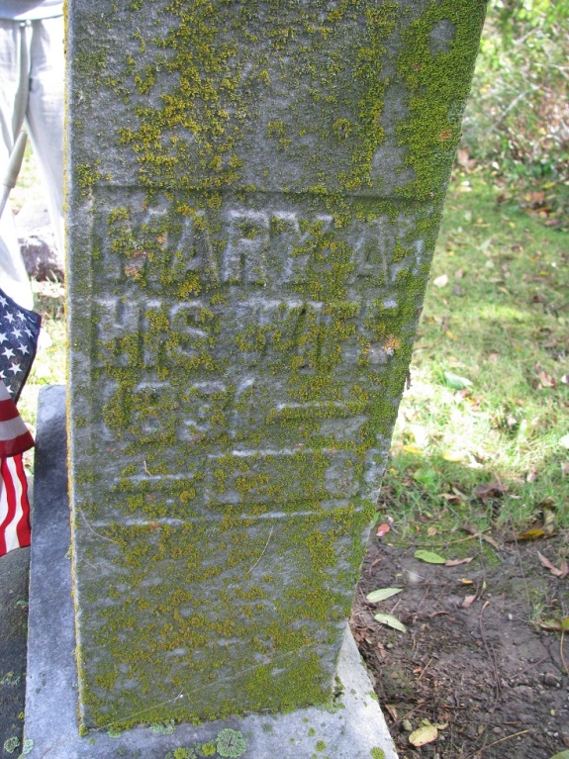
Photos by PLS

Indiana, Death Certificates, 1899-2011

Name: Mary H Armstrong
[Mary H Leffel]
Gender: Female
Race: White
Age: 90y, 4m, 29d
Marital status: Widowed
Birth Date: 22 Jul 1831
Death Date: 21 Dec 1921
Death Place: Pleasan Milld, Adams, Indiana, USA
Father: John Leffel
Spouse: Daniel Armstrong
Informant: John Armstrong
Burial: 12-23-1921; Pleasant Mills

