Zachariah Archer
March 9, 1840 – September 8, 1878

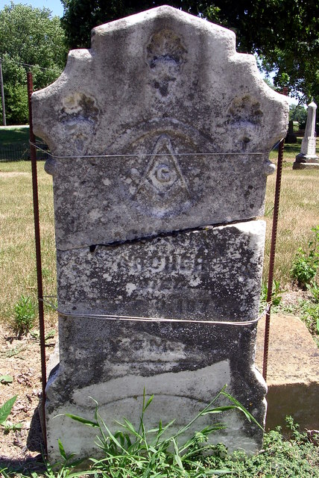
Photo by Deb Curry

Zachariah Archer
in the U.S., Civil War Soldier Records and Profiles, 1861-1865
Name Zachariah Archer
Enlistment Date 28 Aug 1862
Enlistment Rank Private
Muster Date 28 Aug 1862
Muster Place Indiana
Muster Company H
Muster Regiment 89th Infantry
Muster Regiment Type Infantry
Muster Information Enlisted
Rank Change Rank Corpl
Muster Out Date 19 Jul 1865
Muster Out Place Mobile, Alabama
Muster Out Information Mustered Out
Side of War Union
Survived War? Yes
Residence Place Decatur, Indiana
Title Report of the Adjutant General of the State of Indiana

**
Zachariah Archer from tree Archer/Reed Family Tree
Birth 9 Mar (or Sept. 3) 1840 Adams, Indiana, USA
Marriage 18 Oct 1866 Adams, Berkshire, Massachusetts, USA
Residence 1870 Adams, Indiana, USA
Death 3 Sep 1878 Adams, Indiana, USA
Father Aaron Archer (1810-1881)
Mother Jane McClellan (1810-1849)
Spouse Nancy J. Braddock (1840-1872)

