Velma Archer
July 21, 1895 – September 29, 1897

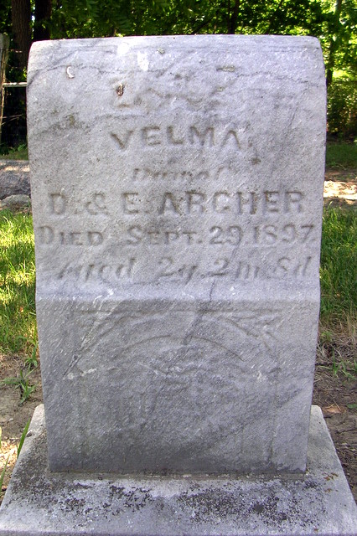
Photo by Deb Curry

Indiana Births, 1880-1920
Name: Archer, ___
Father: David
Mother: Archibold
County: Adams
Gender: Female
Birth Date: 21 Jul 1895
Reference: Adams County, Indiana Index to Birth Records 1882 - 1920 Inclusive Volume I Letters A - Z Inclusive; Book: H-5; Page:2

**
Velma Archer from tree Towne Beer Family Tree
Birth 21 Jul 1895 Adams, Indiana, USA
Death 29 Sep 1897 Adams, Indiana, USA
Father David Archer (1859-1926)
Mother Evaline Archbold (1864-1955)

