Susannah (Harrison) Andrews-Archer-Delavan
November 29, 1830 – June 29, 1910

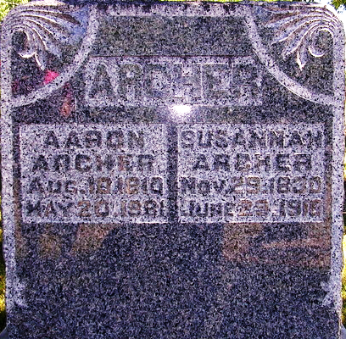
Photo by PLS

PIONEER WOMAN DEAD

Decatur, Ind., June 30. – Mrs. Susannah Archer aged eighty years, one of the pioneer ladies of the county, died yesterday afternoon at 3 o'clock at her home on Line Street after an illness of several months from old age. She had been at the point of death for several days.

The Weekly Sentinel, Allen County, Indiana
July 6, 1910

**
Indiana, Death Certificates, 1899-2011

Name: Susannah Archer
[Susannah Harrison]
Gender: Female
Race: White
Age: 79
Marital status: Widow
Birth Date: 29 Nov 1830
Birth Place: Ohio
Death Date: 29 Jun 1910
Death Place: Decatur, Adams, Indiana, USA
Father: Colombia Harrison
Mother: Catherine Harrison
Spouse: Aaron Archer
Informant: Isabell Winans
Burial: July 3, 1910 - Pleasant Mills, Ind

**
Family Search Record - Indiana Marriages
groom: John H Delavan
groom's race: White; groom's place of birth: , , New York
groom's residence: , Adams, Indiana; groom's number of marriage: 5
groom's father: Oliver Delavan; groom's mother: Elizabeth Pugsley
bride: Susan Archer
bride's race: White; bride's place of birth: , Union,
bride's residence: , Adams, Indiana; bride's number of marriage: 3
bride's father: Columbia Harrison; bride's mother: Catherina Harrison
date of license: 04 Jul 1890
date of marriage: 15 Apr 1890; place of marriage: , Adams, Indiana
record number: 3599; digital folder number: 4186021; number of images: 1

