Nancy J. (Braddock) Archer
December 19, 1840 – October 22, 1872

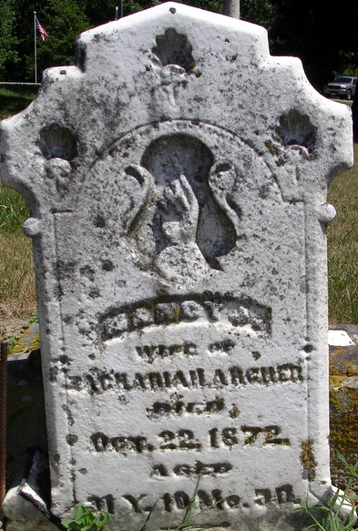
Photo by Deb Curry

Nancy J. Braddock from tree Kinder/Newman Family Tree
Birth 19 Dec 1840 Indiana, USA
Marriage 18 Oct 1866 Adams, Indiana, USA
Residence 1870 Adams, Indiana, USA
Death 22 Oct 1872 Adams, Indiana, USA
Father Francis D. C. Braddock (1814-1888)
Mother Elizabeth J. Gregory (1823-1881)
Spouse Zachariah Archer (1840-1878)

