Harvey H. Archer
March 1, 1883 – February 5, 1884

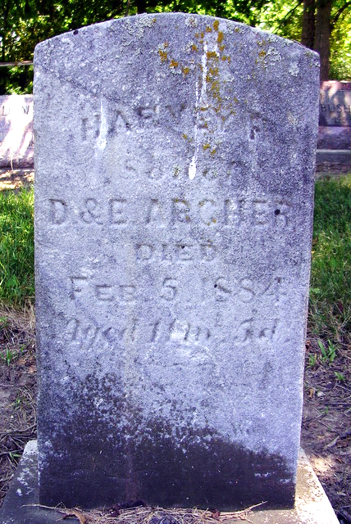
Photo by Deb Curry

Indiana Births, 1880-1920
Name: Harvey Archer
Father: David
Mother: Evaline Archbold
County: Adams
Gender: Male
Birth Date: 1 Mar 1883
Reference: Adams County, Indiana Index to Birth Records 1882 - 1920 Inclusive Volume I Letters A - Z Inclusive; Book: H-1; Page:68
**
Harvey Archer from tree Delores Fawley's Tree
Birth 1 Mar 1883 Indiana, USA
Death 5 Feb 1884 Indiana, USA
Father David Archer (1859-1926)
Mother Evaline L Archbold (1864-1955)

